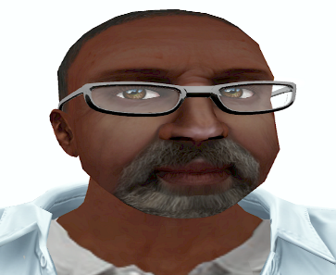
PATIENT: CHARLES GIBSON (CHARLIE)
DOB: OCTOBER 12, 1942
AGE: 74
SEX: MALE
INSURANCE: BC/BS of SENECA
- Reason for Visit
- HPI
- Allergies
Presented to the Emergency Room complaining of a fluttering in his chest for the past couple of weeks on and off. The time of onset of the dizziness and syncope was approximately 30 minutes ago.
Has history of hypertension for which he refuses to take the medication prescribed for him. Patient states "I feel fine without it." He has the medication but has not yet opened the prescription bottle.
Has been diagnosed with Diabetes Mellitus Type II for which he takes Metaforim at 1000 mg/day.
Keeps up with his doctor's visits which are scheduled every four months.
Smokes a half of a pack of cigarettes every day. Cut down from one pack per day over the past couple of years as his doctor told him.
Enjoys all kinds of food including fried food, fast food and "soft drinks".
He has no acute distress.
NKDA

- Initial Visit
BP: 160/100
HEART RATE: 106 rhythm- Atrial fibrillation
RR: 26 even, slightly labored
Pulse ox- 97% on 2L/min oxygen
IV- normal saline 75ml/hr
TEMP: 100.5
WEIGHT: 250 pounds
HEIGHT: 6'0" / 113.398 kg
BMI: 33.9

- Orders
- Lab Results
(time: one hour ago) Orders:
- CT scan stat
- Neuro-surgical consult stat
- Oxygen 2-3Liter. Titrate for an oxygen saturation to > 93%
- Tylenol grX rectal for fever > 100.5
- Two 18gauge needle IVs
- Normal saline 500ml/hour x 1 hour- then 100ml/hour x 6 hours.
- Keep BP systolic < 185 > 110
- Keep diastolic < 105 > 60
- Keep HR > 50 < 110
- 50 mg/ 250 ml [Titrate]- Dosing: Initial: 0.3 to 0.5 mcg/kg/min--increase by 0.5 mcg/kg/min increments.
- May titrate Na nitroprusside to desired BP
- 12- Lead EKG
Labs now:
- CBC with differential
- Complete metabolic panel
- Type and hold
- Coagulation profile
- Comprehensive drug screen with blood alcohol level.
- CK MB isoenzymes
Call me with results of all labs…
(time: Just now) Admit to ICU please
Tissue plasminogen activator now please. Use a 100mg/100ml bag on Normal Saline. Use the dosing chart below.
t-PA Dosing Chart (estimated weight)
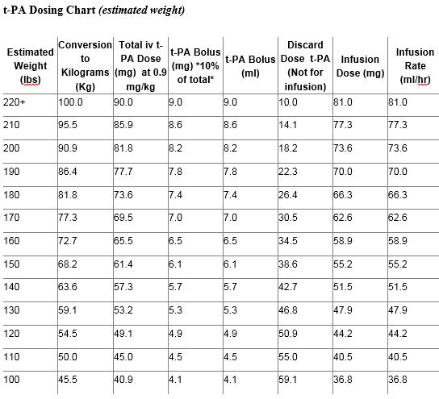
- Do not perform for 24 hours post tPA unless procedure is life-saving: Arterial or central venous punctures/lines, IM injections, nasogastric tubes, Foley catheters
- Place the patient on anticoagulation precautions until 24 hours after the infusion
- Do not give any antithrombotic drugs (including heparin, warfarin, aspirin, clopidogrel, dipyridamole, ticlopidine, or NSAIDS x 24 hrs)-
Blood pressure monitoring:
During the first 24 hours after tPA, monitor BP:
- Every 15 minutes for 2 hours after starting the infusion, then
- Every 30 minutes for 6 hours, then
- Every 60 minutes until 24 hours after starting treatment
If systolic blood pressure is >180 mmHg or if diastolic blood pressure is >105 mmHg for 2 or more readings 5 to 10 minutes apart, use the following guide:
- First tier intervention: Give IV labetalol 10 mg over 1 to 2 minutes. Labetalol may be repeated up to 3 doses every 10 to 20 minutes (doubling doses if needed depending on effect of preceding dose; eg. 1st dose-10mg, 2nd dose- 20mg, 3rd dose- 40mg, then consider drip)
- - For heart rate<60/minute, use hydralazine 5-20mg intravenous over 1-2 minutes every 20-30 minutes. After second bolus, consider second line intervention.
- - Monitor blood pressure and neurologic exam every 15 minutes during treatment and observe for development of hypotension for all 3 tiers of BP interventions.
- Second tier intervention: If 3 doses of labetalol or hydralazine bolus or 30 minutes pass without sufficient BP control, the next step should be a nicardipine drip.
- Third tier intervention: If nicardipine drip fails, then the next step should be a labetalol drip.
**To avoid worsening of cerebral ischemia, target BP of 155-175/85-100.
- Swallow Evaluation in 24 hours.
- When tPA complete, begin IV infusion of Amiodarone
- 150-mg IV bolus over 10 minutes (if necessary, bolus may be repeated in 10 to 30 minutes); then 1 mg per minute for 6 hours; then 0.5 mg per minute for 18 hours; then reduce IV dosage or convert to oral dosing when possible.
Call with results of all labs
- CBC with differential
- Complete metabolic panel
- Type and hold
- Coagulation profile
- Serum comprehensive drug screen with blood alcohol level.
- CK MB isoenzymes
Blood test Results:
White Blood Cell Evaluation
TEST | FULL NAME - NORMALS | PATIENT RESULT
WBC | White Blood Count | 10,000/mm3
Neu, PMN, polys | Absolute neutrophil count, % neutrophils- 50%-75% | 70%
Mono | Absolute monocyte count, % monocytes 0 .6- 9% | 4%
Eos | Absolute eosinophil count, % eosinophils 0.3-7% | 4%
Baso | Absolute basophil count, % basophils 0.3-2% | 1%
RBC Evaluation
TEST | FULL NAME - NORMALS | PATIENT RESULT
RBC | Red Blood Count 3.6-5.0 million/ml | 3 million/ml
Hb | Hemoglobin W- 12-16g/dl | 12g/dl
Hct | Hematocrit W- 38-46% | 36%
Eos | Absolute eosinophil count, % eosinophils 0.3-7% | 4%
Baso | Absolute basophil count, % basophils 0.3-2% | 1%
PLATELET Evaluation
TEST | FULL NAME - NORMALS | PATIENT RESULT
PLT | Platelet Count 150-450,000 | 200,000

TEST | FULL NAME - NORMALS | PATIENT RESULT
Ca+ | Calcium 8.5-10.5mg/dl | 8 mg/dl1
Albumin | Albumin 3.5-5.0g/dl | 4.0 g/dl
Serum total protein | 6.4-8.3 g/dl | 7.5 g/dl
Na+ | 135-145 mEq/L | 135 mEq/L
K+ | 3.5-5.0mEq/L | 4.2 mEq/L
CL | 95-110 | 100
CO2 | 22-26 mEq/L | 24
BUN | 5-15 | 22
Cr | .5-1.5 | 1.5
GLUCOSE | 70-110 | 220
PTT | 25-40 secs | 30
PT | 10-15 secs | 15
INR | 1 | 1
Fibrin split products | 0
D-Dimer (FSP) | < 230 ng/ml
Fibrinogen | - 1. G/dl | < 1 g /dl
Uric acid | 3.5-7 | 7
Lactate level | < 2 | 2

CK MB isoenzymes
CPK-1 (also called CPK-BB) positive
CPK-2 (also called CPK-MB) negative
CPK-3 (also called CPK-MM) negative
Blood alcohol level- 40

Serum comprehensive drug screen
1. Amphetamines neg
2. Methamphetamines neg
3. Barbiturates neg
4. Benzodiazepines neg
5. Marijuana neg
6. Cocaine neg
7. Opiates neg
8. Phencyclidine neg
9. Methadone neg
10. Propoxyphene neg
Type and hold:
Blood type- AB +
Antibodies negative

- Metformin
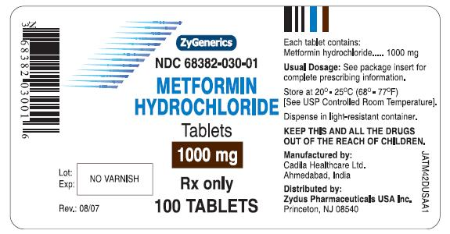

Receives 1000 mg daily

Results of CT scan:
Left side reveals an area of slight hypodensity consistent with an ischemic area on the left . Right side reveals no specific areas of hypodensity.

MD Performed stroke severity scale
(NIH stroke scale)
Consult NIH Stroke Scale Chart
Results revealed:
1a. Level of Consciousness
Scale Definition:
0 = Alert; keenly responsive.
1b. LOC Questions
Scale Definition
0 = Answers both questions correctly
1c. LOC Commands
Scale Definition
0 = Performs both tasks correctly.
2. Best Gaze
Scale Definition
1 = Partial gaze palsy. Gaze is abnormal in one or both eyes, but forced deviation, or total gaze paresis is not present. Able to move one or both eyes, but may not be able to cross midline.
3. Best Visual.
Scale Definition
1 = Partial hemianopia. Includes loss in only one quadrant.
4. Facial Palsy.
Scale Definition
2 = Partial paralysis. Total or near-total paralysis of lower face.
5. Motor Arm. (a. Left Arm, b. Right Arm)
Scale Definition
5a. 0 = No drift. Limb holds 90 (or 45) degrees for a full 10 seconds.
5b. 3 = No effort against gravity. Limb falls.
6. Motor Leg. ( a. Left Leg, b. Right Leg)
Scale Definition
6a. 0 = No drift. Limb holds 90 (or 45) degrees for a full 10 seconds.
6b. 3 = No effort against gravity. Limb falls
7. Limb Ataxia.
Scale Definition
1 = Present in one limb.
8. Sensory.
Scale Definition
1 = Mild to moderate sensory loss. Patient feels pin prick is less sharp or is dull on the affected side or there is a loss of superficial pain with pin prick, but patient is aware of being touched.
9. Best Language.
Scale Definition
2 = Severe aphasia. All communication is through fragmentary expression; great need for inference, questioning and guessing by the listener. Often limited to one-word answers. Range of information that can be exchanged is limited; listener carries burden of communication. Examiner cannot identify materials provided from patient response.
10. Dysarthria.
Scale Definition
2 = Severe dysarthria. Patient’s speech is so slurred as to be unintelligible in the absence of or out of proportion to any dysphasia or is mute.
11. Extinction and Inattention (formerly neglect).
Scale Definition
1 = Visual, tactile, auditory, special or personal inattention or extinction to bilateral simultaneous stimulation in one of the sensory modalities.
Scoring and Outcomes
- 0= no stroke
- 1-4= minor stroke
- 5-15= moderate stroke
- 15-20= moderate/severe stroke
- 21-42= severe stroke
NIH Scale for Patient - 17

